**Title of the Project**

**Lodge Booking Management System**

**Date :** 29/10/2020

**Problem Statement :**

This is a system which is mainly made for management of a Lodge. The project Lodge Booking Management manages and maintains the records of customers and rooms in the lodge. Lodge also has other facilities like restaurant, swimming pool etc. So these charges and records will be maintained accordingly.

This system has been made in a user friendly interface, so that normal person can add, delete and modify the entries of customer and handle the transactions of customers easily.

**List of Classes in your application domain:**

1. User Class
2. Role Class
3. Permission Class
4. Lodge Class
5. Room Class
6. Booking Class
7. Customer Class
8. Payment Class

**Functional requirements of the project :**

1. Easy management of checking –in and other processes.
2. This system saves time.
3. Can give accurate information about lodge when required.
4. Billing becomes easy using this system.
5. Customer information is available anytime.
6. This system also reduces paper work.
7. Easy to use, efficient, and accessible.

**Class Diagram For Lodge Booking Management System:**

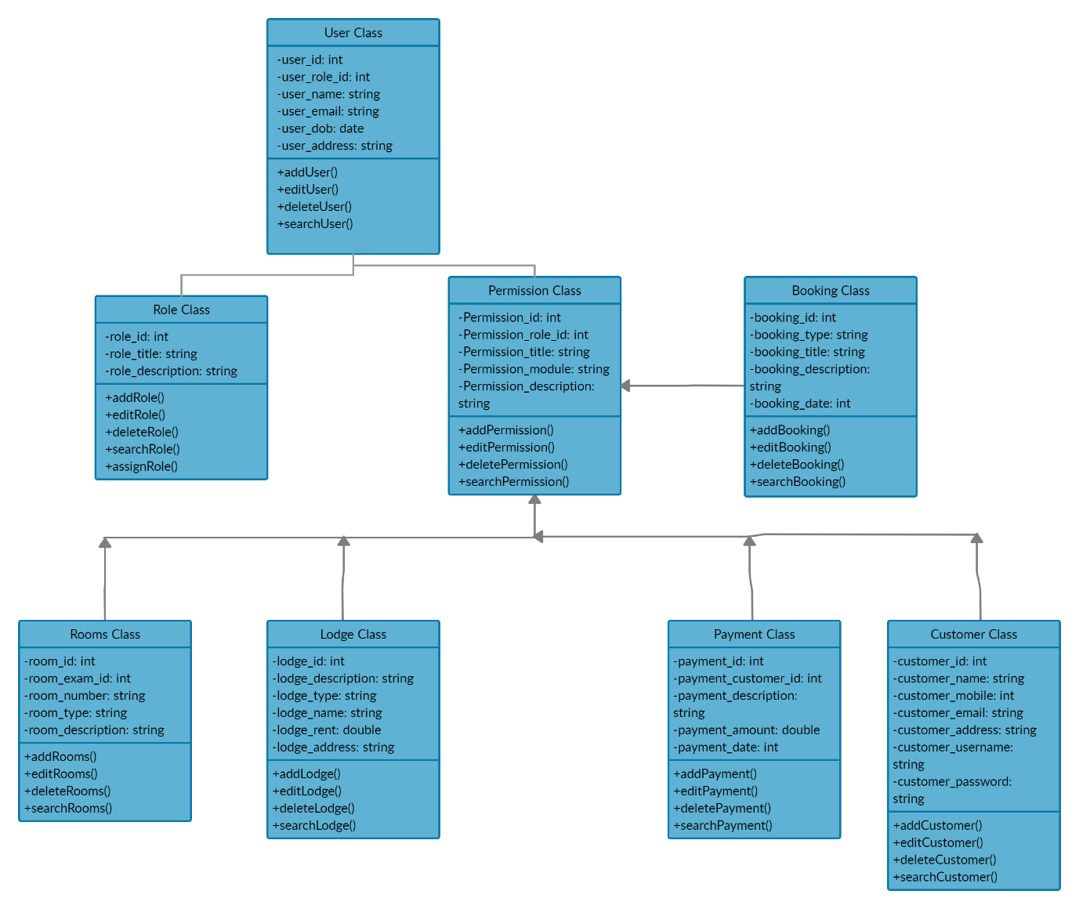

**Group Leader Name and USN : Atreay Kukanur - 2GI19CS028**

**Members :**

**USN NAME**

**2GI19CS008 Aditya Nandeshwar**

**2GI19CS041 Fakkiresh Noorshettar**

**___________________________________________**